|  |  |
| --- | --- |
| Date | 27 October 2022 |
| Team ID | PNT2022TMID33276 |
| Project Name | Machine Learning based on air craft engine |
| Maximum Marks | 4 Marks |

Technology Stack:

Project : Machine learning based on air craft engine

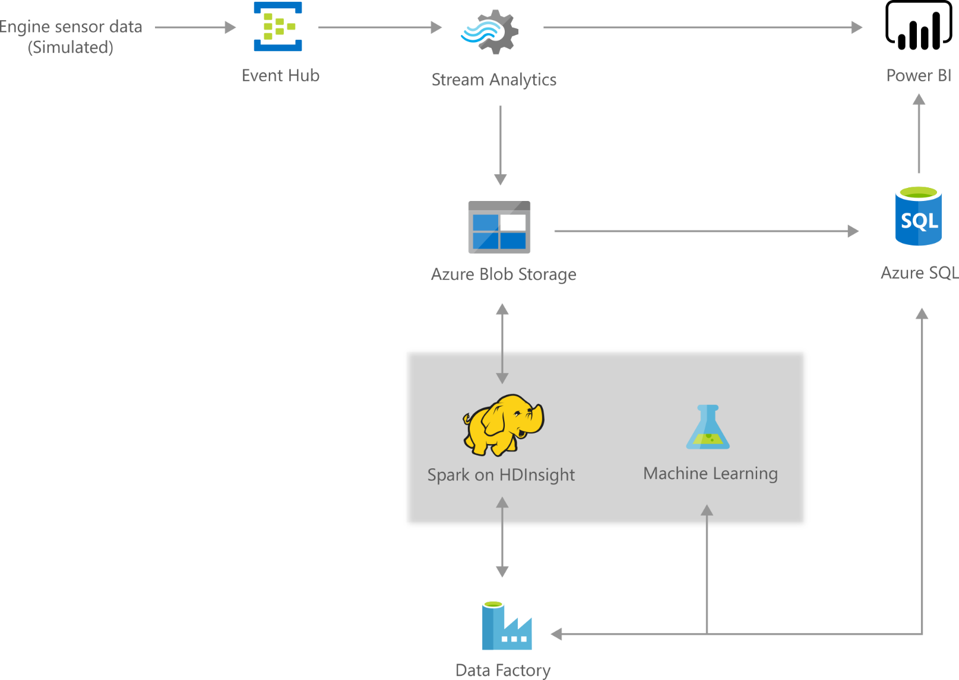

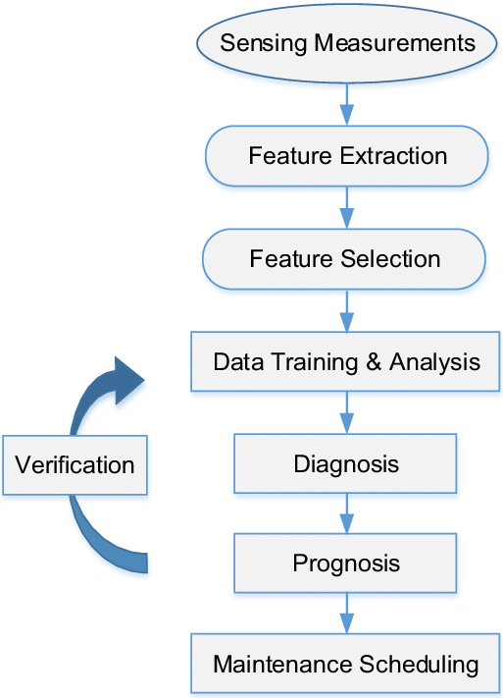

Table-1 :

Components & Technologies:

|  |  |  |  |
| --- | --- | --- | --- |
| s.no | Components | Description | Technology |
| 1. | User Interface | User interacts with application and websites . e.g.Web UI,Mobile App,  Chatbot etc. | HTML,CSS,javaScript/Angular Js/React Js etc |
| 2. | Website Logic-1 | Logic for a process in the application | Python |
| 3. | Website Logic-2 | Logic for a process in the application | IBM Cloud Serivce |
| 4. | Database | Data Type,Configurations etc | MySQL,NoSOL,etc |
| 5. | Cloud Datebase | Database Service on cloud | IBM Cloud |
| 6. | File Storage | File storage requirments | IBM Block Storagr or Other Storagr Service or Local Filesystem |
| 7. | Machine Learning Model | Purpose of Machine Learning Model | Object Recognition Model,ML,etc. |

Table-2:

Application Charcteristics:

|  |  |  |  |
| --- | --- | --- | --- |
| S.No | Compounts | Description | Technology |
| 1. | Open- source Frameworks | List the open -source framework  Used | Python of open source  framework |
| 2. | Security implementation | List all the security/acess controls implemented,use of firewall etc. | Eg.SHA-256,Encryption,IMA controls,OWASP etc. |
| 3. | Scalable Architecture | Justity the scalability of architecture (3-tier,Micro-services) | AIT echnology used |
| 4. | Availability | Justity the availability of application(e.g.use of load balancers,distributedservers etc.) | IBM DB2T Technology used. |
| 5. | Performance | Design consideration for the performed of the application (number of the requests per sec,use of cache,use of CDN’S),etc. | CWMP/USP Technology ued |